Ex1 - Creating a virtual server in AWS public cloud

# Nithin Prasath C – 22BCS081

## AIM:

To provide step-by-step instructions for creating a virtual server in AWS public cloud, including screenshots for each step.

## DESCRIPTION:

Amazon Web Services (AWS) is a comprehensive and widely adopted cloud platform that offers a range of services including computing power, storage, and databases. AWS enables users to run virtually any application in the cloud with flexible, scalable, and cost-effective infrastructure. One of the core services provided by AWS is the Elastic Compute Cloud (EC2), which allows users to create and manage virtual servers, known as instances. In this exercise, we will create a virtual server using AWS EC2.

## OUTPUT:

### Amazon Image:

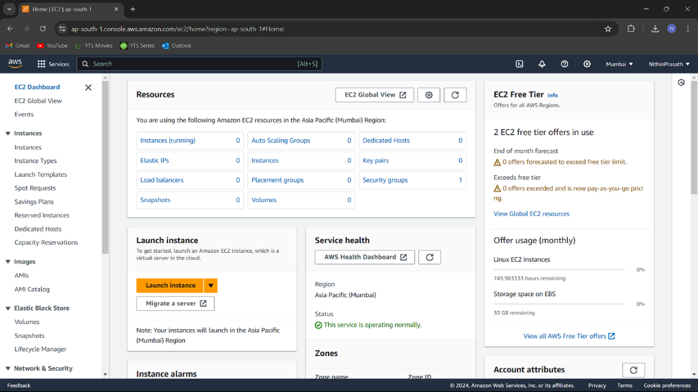

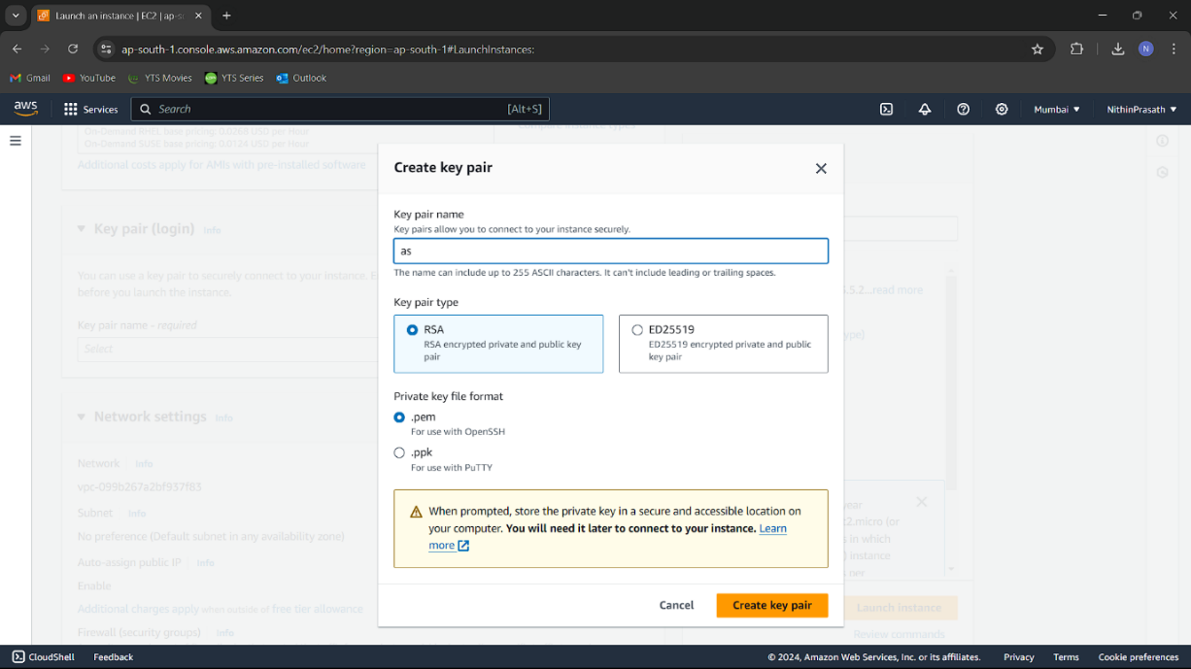

### Windows/Linux/Mac Server

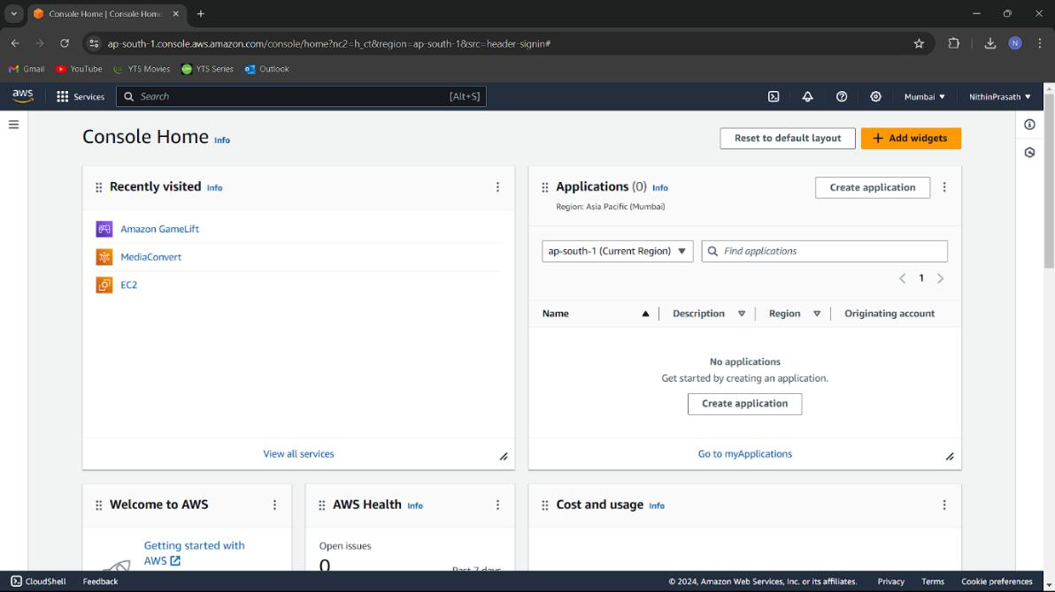

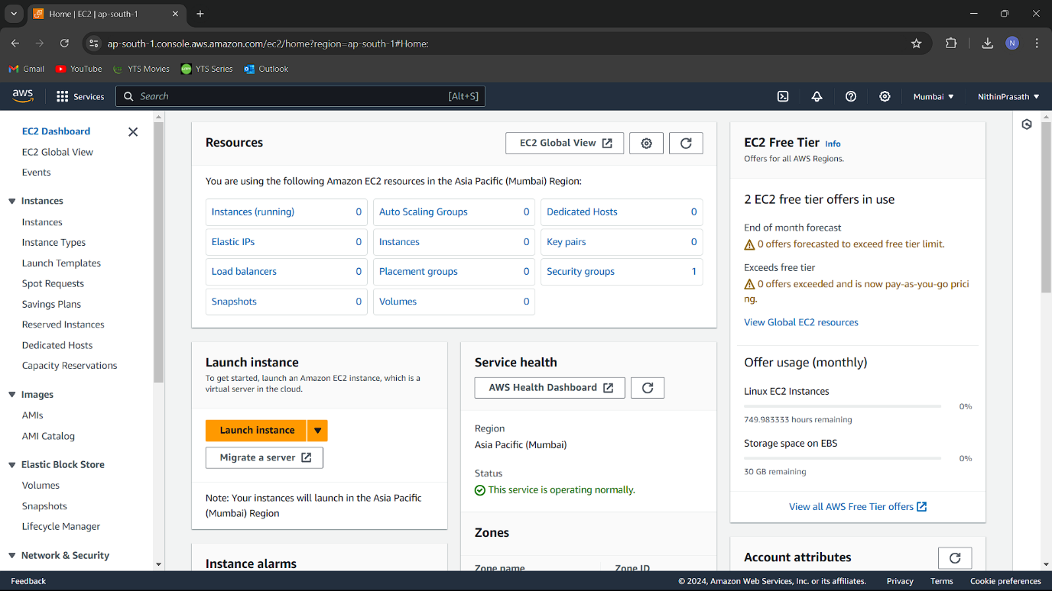

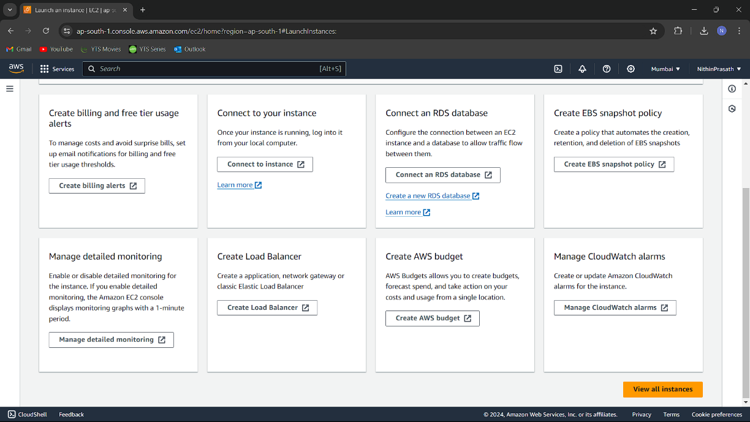

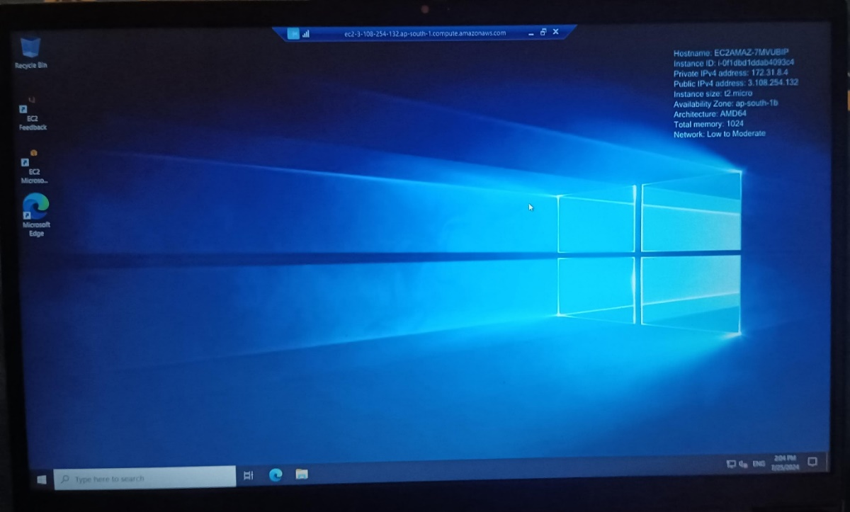

### **Result:**

Successfully created a virtual server in the AWS public cloud using the EC2 service. The instance is now running and accessible. Screenshots are attached to demonstrate each step.